**Name: Ayush Girish Agrawal**

**Emp\_id: INT936**

**Prior Instructions**

* **Please do read all the questions before performing any operations in the database**
* **Once you have fully gone through the questions then likewise decide the contents and table columns and follow the below instructions**

1. Create Student Database

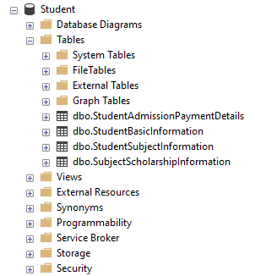

1. Create the following table under the Student Database:

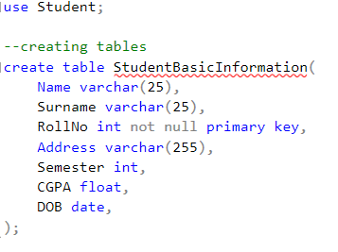

* 1. StudentBasicInformation
     1. Columns
        1. StudentName
        2. StudentSurname
        3. StudentRollNo
        4. StudentAddress
        5. Add more three basic columns of the

name of your own

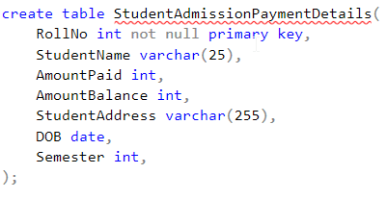

* 1. StudentAdmissionPaymentDetails
     1. Columns
        1. StudentRollNo
        2. AmountPaid
        3. AmountBalance
        4. Add more four basic columns of the

name of your own

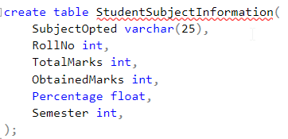

* 1. StudentSubjectInformation
     1. Columns
        1. SubjectOpted
        2. StudentRollNo
        3. SubjectTotalMarks
        4. SubjectObtainedMarks
        5. StudentMarksPercentage
        6. Add more one columns of the

name of your own

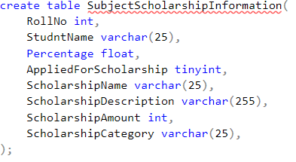

* 1. SubjectScholarshipInformation
     1. Columns
        1. StudentRollNo
        2. ScholarshipName
        3. ScholarshipDescription
        4. ScholarshipAmount
        5. ScholarshipCategory
        6. Add more two columns of the

name of your own

1. 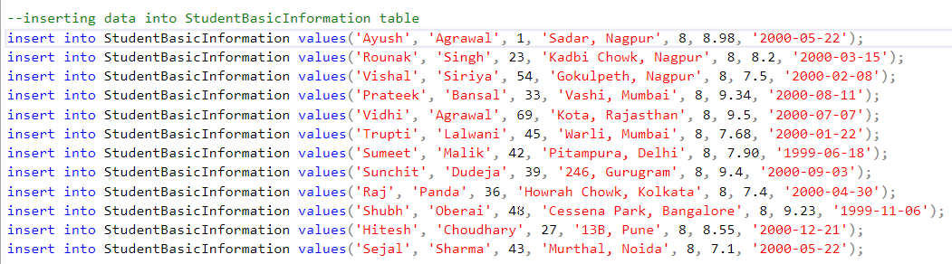Insert more than 10 records in each and every table created

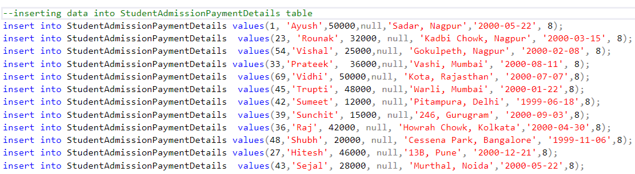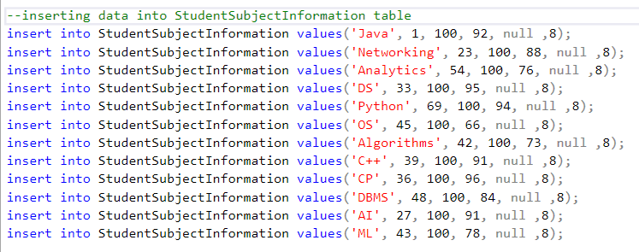

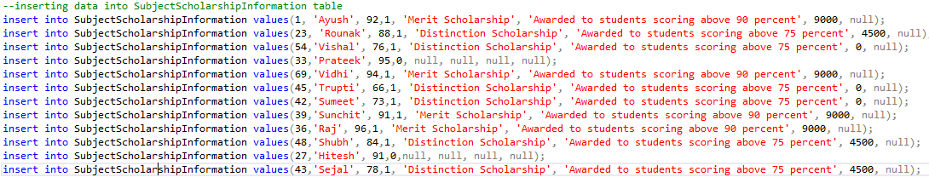

1. 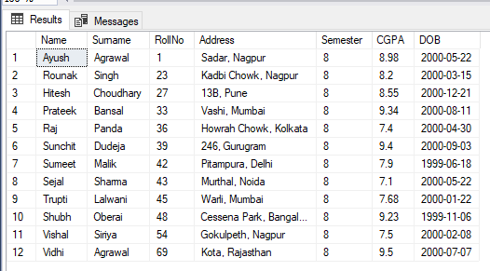Snap of the all the tables once the insertion is completed

**(Some columns are intentionally left null, as they are required to be filled using stored procedures later onwards)**

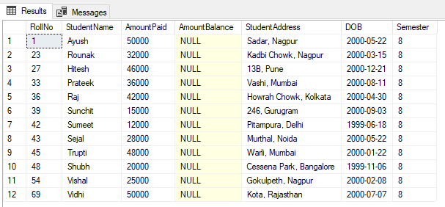

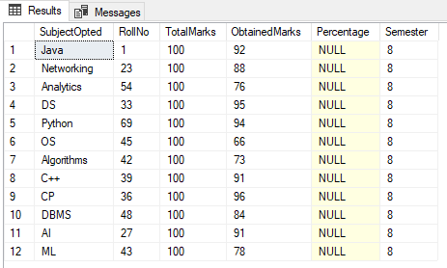

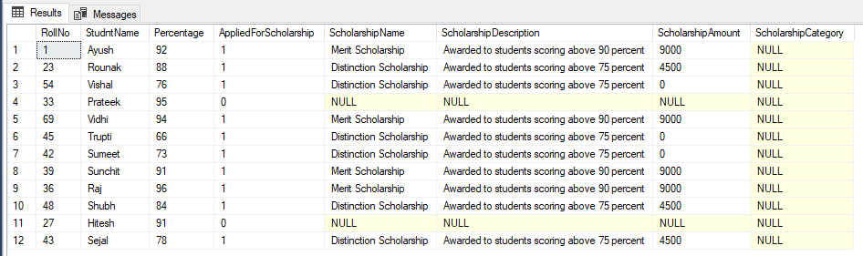

1. 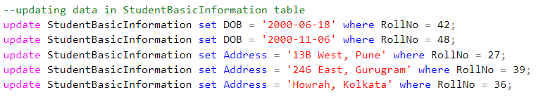Update any 5 records of your choice in any table like update the StudentAddress with some other address content and likewise so on with any records of any table of your choice

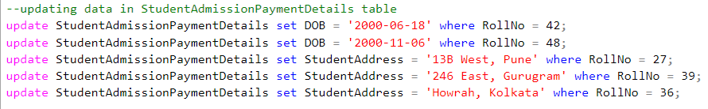

1. Snap of the all the tables post updation

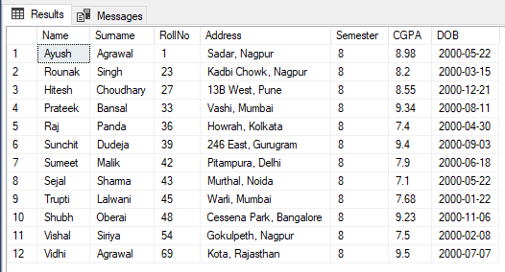

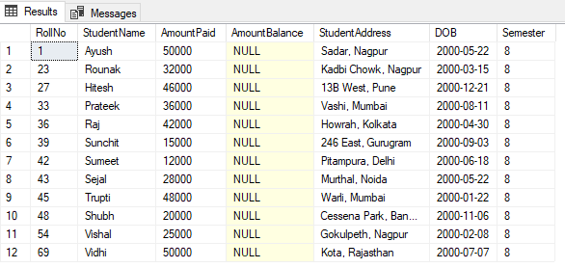

1. Select the student details records who has received the scholarship more than 5000Rs/-

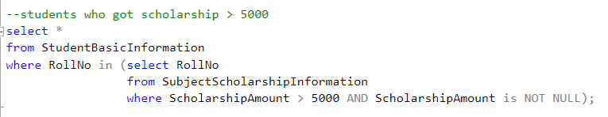

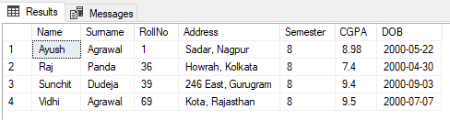

1. Select the students who opted for scholarship but has not got the scholarship

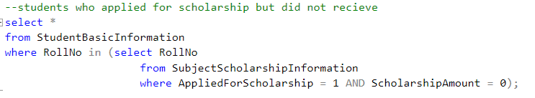

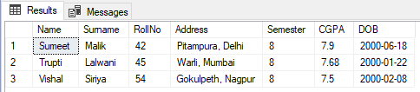

1. Fill in data for the percentage column i.e. StudentMarksPercentage in the table StudentSubjectInformation by creating and using the stored procedure created

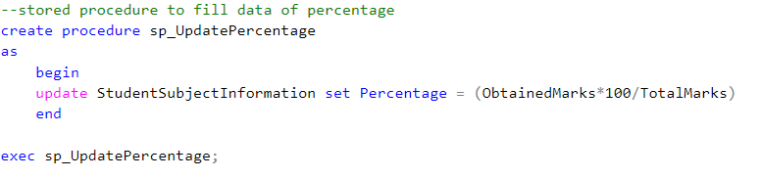

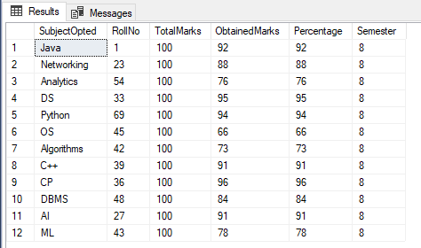

1. Decide the category of the scholarship depending upon the marks/percentage obtained by the student and likewise update the ScholarshipCategory column, create a stored procedure in order to handle this operation

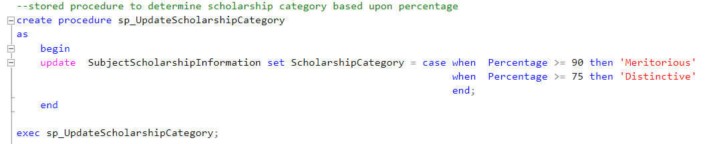

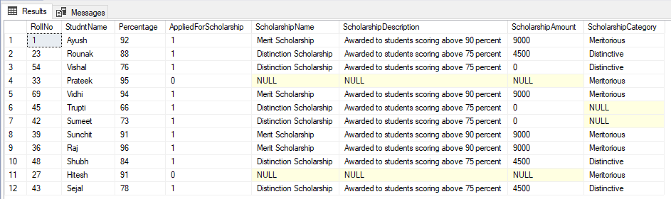

1. Create the View which shows balance amount to be paid by the student along with the student detailed information (use join)

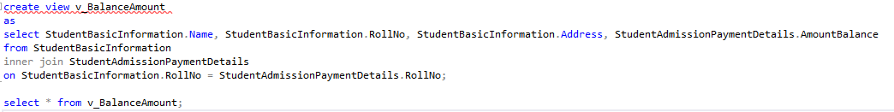

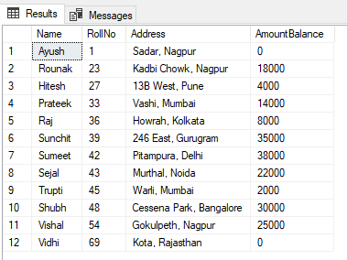

1. Get the details of the students who haven’t got any scholarship (use joins/subqueries)

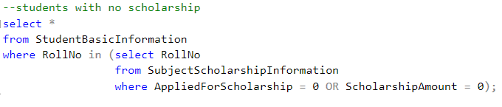

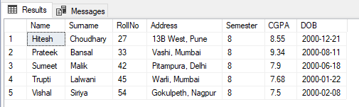

1. Create Stored Procedure which will be return the amount balance to be paid by the student as per the student roll number passed through the stored procedure as the input

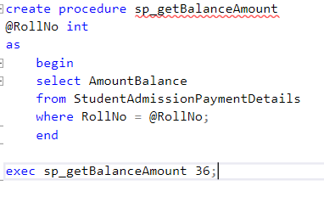

C:\Users\SONY\Desktop\2022-01-26 00_17_05-Window.png

1. Retrieve the top five student details as per the StudentMarksPercentage values (use subqueries)

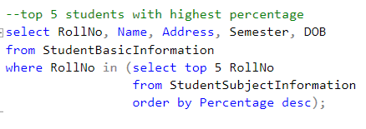

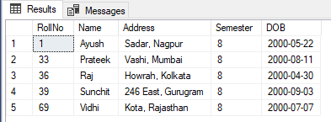

1. Try to use all the three types of join learned today in a relevant way, and explain the same why you thought of using that particular join for your selected scenarios (try to cover relevant and real time scenarios for all the three studied joins)

**1. Inner Join** (using to get the Student Details along with their percentages)

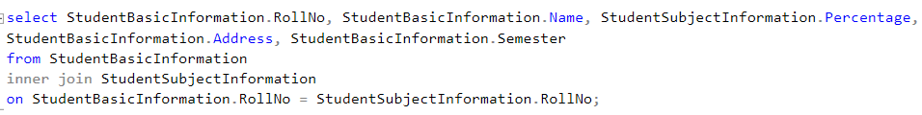

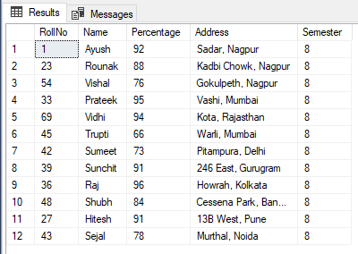

**2. Left Join** (using to get students details who did not apply for scholarship)

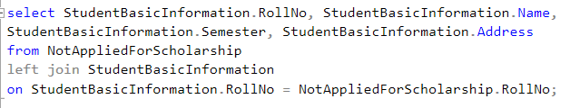

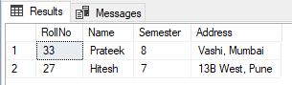

**3. Right Join** (using to get students details who are in 8th sem irrespective of scholarship application)

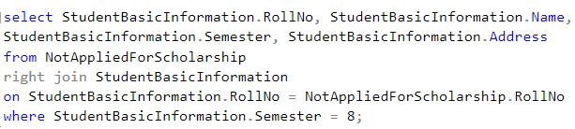

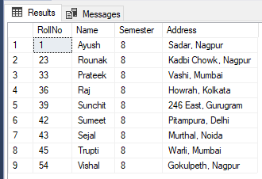

1. Mention the differences between the delete, drop and truncate commands

### **1. Delete:**

It is a [Data Manipulation Language Command (DML)](https://www.geeksforgeeks.org/sql-ddl-dql-dml-dcl-tcl-commands/). It is used to delete one or more tuples of a table. With the help of the “DELETE” command, we can either delete all the rows in one go or can delete rows one by one. i.e., we can use it as per the requirement or the condition using the Where clause. It is comparatively slower than the TRUNCATE command. The TRUNCATE command does not remove the structure of the table.

### **2. Drop:**

It is a Data Definition Language Command (DDL). It is used to drop the whole table. With the help of the “DROP” command we can drop (delete) the whole structure in one go i.e. it removes the named elements of the schema. By using this command the existence of the whole table is finished or say lost. Here we can use the “ROLLBACK” command to restore the tuple because it does not auto-commit.

### **3. Truncate:**

It is also a Data Definition Language Command (DDL). It is used to delete all the rows of a relation (table) in one go. With the help of the “TRUNCATE” command, we can’t delete the single row as here WHERE clause is not used. By using this command the existence of all the rows of the table is lost. It is comparatively faster than the delete command as it deletes all the rows fastly. Here we can’t restore the tuples of the table by using the “ROLLBACK” command.

1. 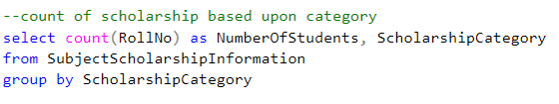Get the count of the Scholarship category which is highly been availed by the students, i.e. get the count of the total number of students corresponding to the each scholarships category

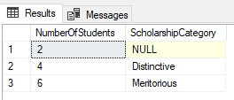

1. Along with the assignment no. 17 try to retrieve the maximum used scholarship category

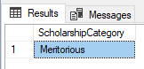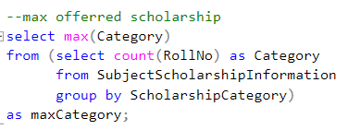

1. Retrieve the percentage of the students along with students detailed information who has scored the highest percentage along with availing the maximum scholarship amount

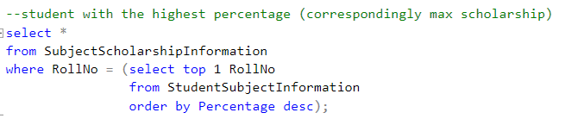



1. Difference between the Triggers, Stored Procedures, Views and Functions

## **Stored Procedure**

A stored procedure is a set of pre-compiled Structured Query Languages (SQL), so it can be reused and shared by multiple programs. It can access or modify data in a database.

## **SQL Function**

A function is a database object in SQL Server. Basically, it is also a set of SQL statements that accept only input parameters and produce output in a single value form or tabular form.

## **Trigger**

A trigger is also a set of SQL statements in the database which automatically execute whenever any special event occurs in the database, like insert, delete, update, etc.

**View**

In SQL, a view is a virtual table based on the result-set of an SQL statement. A view contains rows and columns, just like a real table. The fields in a view are fields from one or more real tables in the database.

## **Difference between Stored Procedure, SQL Function, and Trigger**

**Executable**

Store procedure: We can execute the stored procedures when required.

Function: We can call a function whenever required. Function can't be executed because a function is not in pre-compiled form.

Trigger: Trigger can be executed automatically on specified action on a table like, update, delete, or update.

View: We can execute a view when required

**Calling**

Stored procedure: Stored Procedures can't be called from a function because functions can be called from a select statement and Stored Procedures can't be called from. But you can call Store Procedure from Trigger.

Function: Function can be called from Store Procedure or Trigger.

Trigger: Trigger can’t be called from Store Procedure or Function.

View: View cannot be called from Store Procedure or Function

**Parameter**

Store procedure: Stored Procedures can accept any type of parameter. Stored Procedures also accept out parameter.

Function: Function can accept any type of parameter. But function can’t accept out parameter.

Trigger: We can’t pass a parameter to trigger.

View: We can’t pass a parameter to view.

**Return**

Store procedure: Stored Procedures may or may not return any values (Single or table) on execution.

Function: Function must return any value.

Trigger: Trigger never return value on execution.

View: Views don’t return a value

**Thank you. All The Best. Enjoy The Assignment.**